Walk! Bike! Brockport! Annual Report (2022)
Overview
BoB LeSuer and Rozenn Bailleul-LeSuer are now co-chairs of this committee, which met regularly on the 2nd Tuesday of every month, with a break in August.
New mission statement: Cultivating a vibrant, inclusive community engaged in accessible active transportation and recreation.
New strategic plan: AAA: It’s not just for motor vehicles!
Activity – Let’s do something
- Develop “jaunts around the village” based upon the BCM historical tour. Promote routes established by BCM, incorporate cyclists, include a social component (coffee follow-up)
- Promote neighborhood walks (learn about who is dog walking and kid strolling in your neighborhood and encourage doing it together)
- Biking the Erie Canal events, given the importance of 2023 – bicentennial of Erie Canal.
Awareness – let’s learn and promote something
- Raise awareness for active recreation opportunities for aging population through promotional materials and face-to-face outreach.
- How to be a good biker (creating promotional materials – for example a Brockport biker centric video) about prudent practices in village cycling safety and courtesy.
- Promote use of the website as a source of information (that doesn’t track you or steal your information for commercial purposes)
Advocacy - let’s support something
- Village speed limits – ensuring village controlled streets are safe for cyclists and pedestrians
- Partnering with PTNY initiatives at the county/state level
- Double parking on main street
New website: walkbikebrockport.org. Thanks to Garrett Roe, we also continue to have a regular presence on social media (mostly Facebook).
Activities: Our goal is to provide year round opportunities in the Village.
- Participation in the 2022 Erie Canalway challenge (https://eriecanalway.org/explore/challenge): we had 22 members who completed 3,475 miles (walking and biking).
- Canal Clean Sweep on Earth day (April 22)
- Low Bridge high Water: June 11, 2022
- Cycle the Erie Canal: July 11, 2022
- Walk to School Day: October 5, 2022
- Bike to Holley Falls in October: October 15, 2022
- Midnight madness: October 28, 2022
Special Kudos to Garrett Roe for participating in many active transportation activities during the year such as being a On the Canals excursions’ leader.

Continued Participation:
- We maintain a presence in the village committee “Bridging the Closure,” which aims at getting the community ready to handle the closure of Main Street while the bridge is being repaired.
- We are paying attention to the Monroe County Active Transportation Plan currently under development by having members attend the meetings.
- Brockport has been selected to be a pilot community for the Empire State Trail Town program developed by Parks and Trail New York (PTNY) and the New York State Canal Corporation (https://www.ptny.org/our-work/support/canalway-trail-partnership/empire-state-trail-towns). We have been working closely all year with members of PTNY by facilitating and supporting the activities they organized in the village this year:
  - Listening session in May and slow roll around Brockport
  - helped with survey promotion (Empire State Trail Survey)
  - bike friendly certification (for businesses)
  - bicycles bring business presentation (October)
Plans for next year:
- Review and implement PTNY recommendations in the report they will submit to the village as part of the Empire State Trail Town program.
- Membership drive
- Involve more SUNY Brockport students via internships
- Continue to work on promoting our activities and our wonderful volunteers
- Create an Event Calendar
- More activities:
  - First Day event (snowshoeing on 1/1/23: place and time TBD)
  - Add a Bike to School Day
- Advocacy:
  - support the proposal to reduce village speed limit and to add rectangular rapid flashing beacon (RRFB) at Park Avenue and other high traffic areas
- Re-visit access to the Brockport Woods Nature Preserve near SUNY campus.
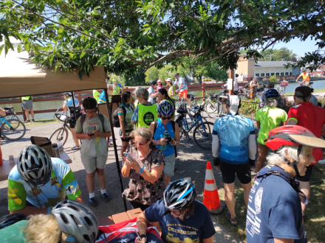  More than 600 bikers rode through the village on July 11. | 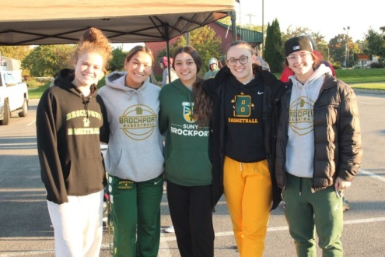  SUNY Brockport volunteers for Walk to School Day | 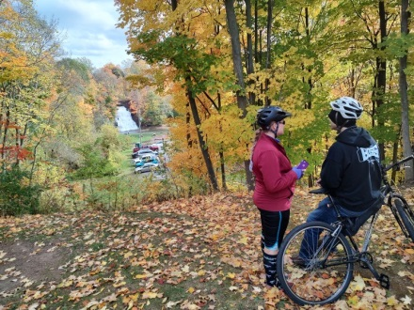  Perfect weather to bike to Holley Falls on October 15

